**Interdecadal alterations in frugivore abundance and diversity in a Congo Basin tropical rainforest: the Bouamir Story**

**Emily Chen1, Jesse Garcia1, Marina Kameni2, and Taylor Roswall1**

**1***Department of Ecology and Evolutionary Biology, University of California Los Angeles, Los Angeles, CA 90095-1606, USA*

**2** *Laboratory of Zoology, Faculty of Science, University of Yaoundé I, Yaoundé, Cameroon*

**Abstract**

We resurveyed frugivore abundance at the Bouamir field site, Dja Biosphere Reserve, Cameroon, using distance sampling to estimate changes in abundance, diversity, and local distribution by comparing survey data from January and February 1999 and 2017. Of the 16 frugivorous species surveyed, only four showed significant changes over the past 18 years. Estimated abundances of the African pied hornbill (*Tockus fasciatus*), the black-casqued hornbill (*Ceratogymna atrata*), and the moustached monkey (*Cercopithecus cephus*) in 2017 rose compared to previous levels in 1999. Conversely, abundances for grey-cheeked mangabey (*Lophocebus albigena*) decreased from 1999 levels. A significant decrease in Shannon’s diversity and Shannon’s equitability indices occurred across time periods despite no changes in species richness, which suggests that frugivores were distributed more equitably in 1999 compared to 2017. We posit that changes in species composition can likely be attributed to selective harvesting of bushmeat, international trade, and possibly altered environmental variables such as fruiting phenology. By comparing measures of biodiversity through time in addition to tracking species’ population trends, our results can direct conservation efforts towards the exact species and spaces that are most sensitive to stressors and disturbances.

**Résumé**

En utilisant la distance d’échantillonnage, Nous avons réévalué les abondances, la diversité et la distribution locale des frugivores dans la réserve de biosphère du Dja au Cameroun. Les données d’échantillonnage d’hiver 1999 (saison sèche) ont été comparées avec celles de l’hiver 2017. Parmi les 16 espèces de frugivores recensées, des variations significatives de l’abondance n’ont été observées que chez 04(quatre) espèces entre les deux périodes. Les abondances du calao longibande (*Tockus fasciatus),* du calao à casque noir (*Ceratogymna atrata)* et du hocheur(*Cercopithecus cephus*) ont augmenté par rapport à celles de 1999 (p<0.05). Par contre, l’abondance du Mangabey à joue blanche (*Lophocebus albigena*) a réduit par rapport à celle de 1999 (p < 0.05 ). La baisse significative des indices de diversité de Shanon et d’Equitabilité entre les différentes périodes de temps (Hutcheson T-test, p < 0.05), la richesse spécifique étant la même, montrent que les frugivores dans le Dja était plus équitablement repartie en 1999 qu’en 2017. Nous pensons que la baisse de la biodiversité ainsi que la variation dans la composition des espèces peut être attribué aux dégâts causés par le braconnage pour la consommation de la viande de brousse et le commerce international des animaux. En comparant les mesures de biodiversité en fonction du temps en addition avec le suivi des espèces et le mouvement des populations, nos résultats peuvent orienter les efforts de conservation vers les problèmes précis, les espèces ainsi que les habitats qui sont sensibles aux stress environnementaux extrêmes.

Housing the second largest tropical rainforest on Earth, the Congo Basin is home to hundreds of species of birds and mammals and thousands of species of plants, many of which are endemic to the region (Endamana et al. 2016). Congo Basin rainforests provide tangible benefits to local human populations, through food and medicine, and also serve as a carbon reservoir and a biodiversity hotspot for the entire world (Celine et al. 2013). At the turn of the 21st century, an estimated 3.4 million hectares of African forest were lost annually, much of which occurred in the Congo Basin (Galford et al. 2015). In addition to forest clearings, illegal hunting pressures have disproportionately targeted certain species in the region (Fa et al. 2005). As a consequence, long-term data assessments of biological diversity are essential to understanding the repercussions of changes in biotic and abiotic features over time and determining the most effective means of conservation (Green & Dissanyake 2009).

The Dja Biosphere Reserve was first established as a faunal reserve in 1950 (Muchaal & Ngandjui 1999). The 526,000-hectare reserve comprised of lowland rainforest is the largest reserve in Cameroon and the fifth largest protected area in the Congo Basin (Muchaal & Ngandjui 1999, Wang et al. 2007). Large protected areas, such as the Dja, are critical to conservation because they are resistant to anthropogenic stressors such as habitat fragmentation and can serve as refuge for threatened species (Poulsen et al. 2017). Known for its species richness in plants and mammals, the Dja Reserve contains 107 species of mammals including flagship species such as the forest elephant *(Loxodonta cyclotis*), the western lowland gorilla (*Gorilla gorilla*), the chimpanzee (*Pan troglodytes*), the bongo (*Tragelaphus eurycerus*), and the leopard (*Panthera pardus*) (World Heritage Centre 2016). The Dja was estimated to be 90 percent undisturbed in 1987 when the reserve was placed on the World Heritage List (World Heritage Centre 2016). Currently, however, the reserve is threatened by poaching, construction of the Mékim Dam on the Dja River, and peripheral deforestation (World Heritage Centre 2016).

It is estimated that 80 percent of Central Africa’s trees have fruits and seeds that are adapted for dispersal by vertebrates (Jordano 1992). Knowledge of their abundance is essential for understanding processes involved in forest regeneration and vertebrate-tree interactions, particularly plant gene flow and seed dispersal (Whitney et al. 1998, Wang 2007). From 1994 to 1999, frugivore feeding and abundance (FFA) surveys were conducted on the 25km2 study area surrounding the Bouamir Research Station to monitor frugivore species diversity and abundance. Although a multitude of animals consume fruit, FFA surveys were restricted to larger frugivorous birds and primates. Hornbills comprised a majority of the study species because they are predicted to disperse 22% of the 260 tree species at the Bouamir Research Station field site, while the arboreal primates surveyed were estimated to disperse at least 45 different tree and liana species (Whitney et al. 1998).

Compared to the periphery of the reserve, the Bouamir study area has experienced no logging and very little hunting pressures (Muchaal & Ngandjui 1999, Wang et al. 2007). Unfortunately, the closing of the research station in 1999 left the area exposed to illegal hunting pressures, which likely targeted specific species (Campbell et al. 2011). We resurveyed the Bouamir Research Station in the same manner as was done throughout the 1990s (Whitney et al. 1998, Wang et al. 2007) to assess possible changes in species’ diversity and abundance that may have taken place while the research station was closed. Longitudinal studies of this time frame are uncommon due to their time-consuming nature; this study is the first of its kind in the Dja Biosphere Reserve.

In a critical period when the Dja Reserve is both a host to numerous endangered species and threatened by multiple anthropogenic stressors, our study aims to provide important baselines for future conservation efforts. Human disturbances can affect species populations differently, which can lead to shifts in prevalence, composition, and range, increasing the need for documenting and understanding population dynamics and trends. The goal of our study is to determine the changes in frugivore diversity and distribution that have taken place since 1999. Additionally, we aim to evaluate these changes within each species of frugivore. Lastly, we attempt to visualize the past and present distributions of species to assess the possibility of changing environmental preferences.

**Methods**

The study site surrounds the Bouamir Research Station (3°11'27"N, 12°48'41"E) in the center of the Dja Reserve and encompasses 25km2 of primary forest. We followed surveying methods of the Dja Hornbill Project (Wang et al. 2007). We surveyed each man-made trail within the Bouamir Research Station area four times, for a total of 69 km of trail. Because some of the trails from the 1999 survey were inaccessible, only 10 of the 19 trails from the original Dja Hornbill Project were surveyed (Appendix A). Our surveys were conducted between 0600–1200 h from January 31, 2017 - February 12, 2017 with a walking speed of approximately 2.0 km/hr. Each of the surveys was conducted with one Baka guide and two researchers, although a few surveys were conducted with three to five researchers. For each encounter with a frugivore, we recorded the species, estimated number of individuals, observer to animal distance, angle to species location, distance from start of trail, time of sighting, type of encounter, and the GPS coordinates of the location on the trail. There was potential for certain biases to arise during our observations. To avoid sampling the same trail during the same time of day and in the same direction, we adopted the approach from Wang et al. (2007), reversing the order in which we walked the trails on consecutive transects. Inclement weather could also bias our results toward a lower overall abundance. We therefore restricted our surveys to days free of heavy rain, which only prevented us from surveying one day.

To quantify changes in biodiversity surrounding the Bouamir Research Station, we computed Shannon’s diversity, Shannon’s equitability, and the estimated abundances of frugivorous species during January and February 1999 and January and February 2017. Between January 5, 1999 and February 25, 1999, the same 17.3 km of Bouamir trails were surveyed four times, and this raw data was used to compute biodiversity indices and abundances (Whitney et. al, Unpublished results). About five percent of the raw data were missing values or incomprehensible, so they were excluded from our calculations. Diversity indices like Shannon’s diversity index have relatively high power in differentiating biodiversity at different sites and depend less on sampling effort than other indices (Magurran et al. 2010, Morris et al 2014). A Hutcheson’s *t*-test was used to compute the statistical significance of these indices (Hutcheson 1970). To predict abundances of frugivores at Bouamir, we utilized distance sampling (Buckland et. al 2005) and the R package *Distance* (Miller 2016). To alleviate biases such as human error and inadequate modelling while calculating diversity, we decided to calculate Shannon’s diversity indices using both the *Distance* estimated abundances as well as our encounter abundances.

To compare contemporary species’ spatial distributions with their distributions in 1999, we transformed historical species encounter events into GPS coordinates using ArcMap 10.1 (ESRI 2012). Observations from January and February 1999 were georeferenced using two pieces of information: the name of the trail the observation was taken on and the distance each observation was from the starting point of the trail. Surveys completed in January 2017 and February 2017 used Garmin eTrex 20x GPS units and did not require any georeferencing. Heat maps were created using ArcMap’s Kernel Density Tool with a search radius of 800 meters.

**Results**

*Primates*

Out of the four primate species we calculated estimates of abundance, two species had statistically significant differences in estimates (95% Bootstrapped Confidence Interval, p < .05) from 1999 to 2017: the grey-cheeked mangabey (*Lophocebus albigena*) and the moustached monkey (*Cercopithecus cephus*). Abundance of the grey-cheeked mangabey was found to have decreased from 367.7 to 32.4 individuals, while in contrast, moustached monkeys were found to have increased from 67.8 to 451.1 individuals (Table 1 & Fig. 1A). Although we encountered the black-and-white colobus (*Colobus guereza*)and the chimpanzee (*Pan troglodytes*)during 2017 surveys, *Distance* failed to create a model that could estimate the abundances of these species.

*Birds*

Two species, the black-casqued hornbill (*Ceratogymna atrata*) and the African pied hornbill (*Tockus fasciatus faciatus*), showed statistically significant increases in abundance (95% Bootstrapped Confidence Interval, p < .05) from 1999 to 2017. Black-casqued hornbills were found to have increased from 129.3 to 1259.7 individuals, while African pied hornbills were found to have increased from 64.7 to 583.3 individuals (Table 1 & Fig. 1B).

*Shannon’s diversity index*

From 1999 and 2017 survey data, we calculated biodiversity indices using both estimated abundances from *Distance* and encountered abundances. Estimated abundances using *Distance* from 1999 yielded a Shannon’s diversity index of 2.245 and a Shannon’s equitability of 0.755, while estimated abundances from 2017 yielded a Shannon’s diversity index of 2.093 and a Shannon’s equitability value of 0.793. We also calculated abundance as a measure of the total individuals we encountered while surveying ‒ the encounter abundance. Encounter abundances from 1999 yielded a Shannon’s diversity Index of 2.277 and a Shannon’s equitability of 0.821, while encounter abundances from 2017 yielded a Shannon’s diversity Index of 2.133 and a Shannon’s equitability of 0.769. Based on *Distance* and encounter abundance estimates, Shannon’s diversity index was greater in 1999 than 2017. (Hutcheson’s *t*-test, *Distance* t = 6.52, p < .005, encounter abundances t = 3.49 p < .005 ) **(**Fig. 4, Fig. 5**)**.

**Discussion**

Based on the resurveys, the diversity of frugivores at Bouamir appears to have been higher in January - February 1999 than in January - February 2017 (Fig. 4 & Fig. 5). Although species richness has not changed, changes in the abundance of some species has reduced the evenness of the community **(**Fig. 3**)**. Anthropogenic stressors often disrupt evenness of a community more readily than they disrupt species richness (Chapin et al. 2000). Although the purpose of our study was not to pinpoint the exact stressors effecting changes in biodiversity at Bouamir, human caused caused stressors such as climate change, habitat alterations, and deletion or addition of species in food webs, can greatly disrupt evenness (Lemieux & Cusson 2014). These changes in species evenness are not inconsequential. Destabilization of an ecosystem’s evenness affects important ecological processes much sooner than species extinctions do and therefore warrant scrutiny and remediation (Chapin et al. 2000). Bouamir already has detectable signals of a changing species evenness, and without continuous conservation efforts diversity may continue to deteriorate.

Our results showed a decrease in abundance of grey-cheeked mangabeys, but an increase in abundance of moustached monkeys, while white-nosed guenons (*Cercopithecus nictitans*) and crowned-guenons (*Cercopithecus pogonias*) trended toward a greater abundance as well **(**Fig. 1A**)**. One of the largest threats to primates in the Dja Reserve is hunting (WHC 2016). Primates are preferentially targeted by size (Oates 1996, Fa et al. 2015), ease of capture (Fa et al. 2005) and value. Moustached monkeys(avg mass 3.5kg)and crowned guenons (avg mass 3.7kg) may be experiencing lower hunting pressures due to its smaller body size (Kingdon 2015). Conversely, the grey-cheeked mangabey(avg mass 7.5kg) is the largest of the four species and may have been more intensively targeted (Kingdon 2015). Grey-cheeked mangabeys exhibit mobbing and vocalization behavior, thus rendering them a more easily targeted species, which is most likely the root cause of the species’ frequent harvests in West and Central Africa (Fa et al. 2005, Remis & Jost Robinson 2012). Not all primates are harvested at an equal proportion to their encounter rate. White-nosed guenons have been shown to be hunted less frequently than expected based on its rate of encounter compared to other species, which generally have an equal ratio of being encountered and hunted (Remis & Jost Robinson 2012). In addition, white-nosed guenons appear to be more resilient against hunting pressures and habitat disturbances and have increased in abundances in regions of habitat fragmentation likely due to its partially insectivorous diet and ability to exploit alternative food sources. (Baya & Storch 2010, Remis & Jost Robinson 2012). Crowned guenons may be more resistant to hunting as crowned guenons are generally faster and harder to capture than other primates (Kumpel 2006, Remis & Jost Robinson 2012). Even though some species have increased in abundance due to selective hunting pressures in the past twenty years, as demand grows and access to shotguns increases, less commonly harvested primates, such as the crowned guenon and the moustached monkey, and more resilient species such as the white-nosed guenon could become at risk.

The most noticeable difference in composition of frugivorous birds is the large increase in black-casqued hornbills and African pied hornbills and the trend towards decline in African grey parrots. In 1999, 20 percent of the surveyed frugivores were African grey parrots*,* as compared to 2017 where black-casqued hornbills made up 25 percent of our encountered individuals. While African hornbills are not threatened, populations are declining and are sometimes locally extirpated (Trail 2007). Our results, however, estimated that Bouamir’s population of hornbills have either increased in abundance or remained stable. It is unclear why some hornbill populations, such as the black-casqued hornbill, showed such a dramatic increase in abundance since 1999, especially since these hornbills with large home ranges are particularly vulnerable to habitat fragmentation (Whitney and Smith 1998, Holbrook et al. 2002). While mammals are the primary targets of hunting and trade, hornbills have also been hunted (mostly black-casqued hornbills) for bushmeat and traded internationally (Fa et al. 2006, Trail 2007). Potential explanations for the increase in abundance of these hornbills would require future investigation but could include changes in unsurveyed frugivore populations or environmental variables such as changes in the timing of fruiting phenology.

Opposite to the hornbills, the African grey parrothad a trending decrease in abundance. Surveys from 1999 occasionally observed African grey parrotsin large flocks of 40-60 individuals, while 2017 surveys primarily recorded African grey parrottraveling in pairs and did not encounter these large flocks. The African grey parrotis listed as endangered (BirdLife International 2016) and is estimated to have declined by 99% in some regions due primarily to international pet trade, but also to habitat loss via deforestation (Annorbah et al. 2016). Although Cameroon is the largest exporter of African grey parrots, populations have experienced less of a dramatic decline, especially in protected areas (Marsden et al. 2016). Therefore, protected areas, such as the Dja Reserve, may serve as a final stronghold for this species.

While our study showed clear population differences over the 18-year period, there were issues that may have biased the results. The program we used to calculate abundance estimates (*Distance*) is based on five different assumptions and the sampling methods from 1999 and 2017 failed to meet two of these assumptions (Miller 2016). First, our study was not conducted on randomly placed transects, but along man made trails. Additionally, our perpendicular distances and number of animals were not measured free of human error. Although failing to meet these assumptions could bias our estimated abundances, the same trails and Baka guides were used during both studies, so we assume that these biases affected the abundance estimates equally for both years. Therefore, comparative conclusions can be made by using the estimated abundance results as relative abundances.

Another potential source of bias stems from our extensive use of historical data. We had to remove a small percentage of data from 1999 because it either lacked information needed to calculate the perpendicular distance, a value required for *Distance* to create predictive models, or estimated trail distances that were outside the range of the measured trail distances and could not be transformed to fit onto maps. This removal of data resulted in more conservative abundances and diversity estimates for 1999, which only strengthens our confidence in Bouamir’s diversity decrease over the past twenty years.

*Future Directions*

Longitudinal studies that assess the same transects between decades are rare due to their high demand of effort and resources (Marsden et al. 2016). Our study provides valuable insight into the current status of biodiversity in the Dja Reserve and in the Congo Basin. The results are indicative that large protected areas are also affected by anthropogenic pressures. With our GPS and georeferenced data, we were able to visualize changes in the spatial distributions of species at Bouamir **(** Fig. 2 & Fig.6 **)**. However, lack of adequate data, both because of poor satellite imagery and absence of a weather station, prevented our study from assigning environmental variables to these changes. Future analysis could use high-resolution remote sensing data to attribute changes in distribution to changes in environmental variables. Quantified life history traits of species and multivariable regressions could identify phenotypic traits that are predictive of abundance decline and/or rise. Additionally, current genomic techniques can predict changes in effective population size over time and could be compared to our patterns of abundance rise and fall. Understanding how frugivores’ diversity and abundances respond to changing biotic and abiotic variables is critical to predicting future abundances in areas and establishing protected zones.

**Acknowledgements**

This research was funded by the Department of Ecology and Evolutionary Biology and the National Science Foundation grants IIA PIRE #1243524, DEB-9726425 and IRCEB9977072.

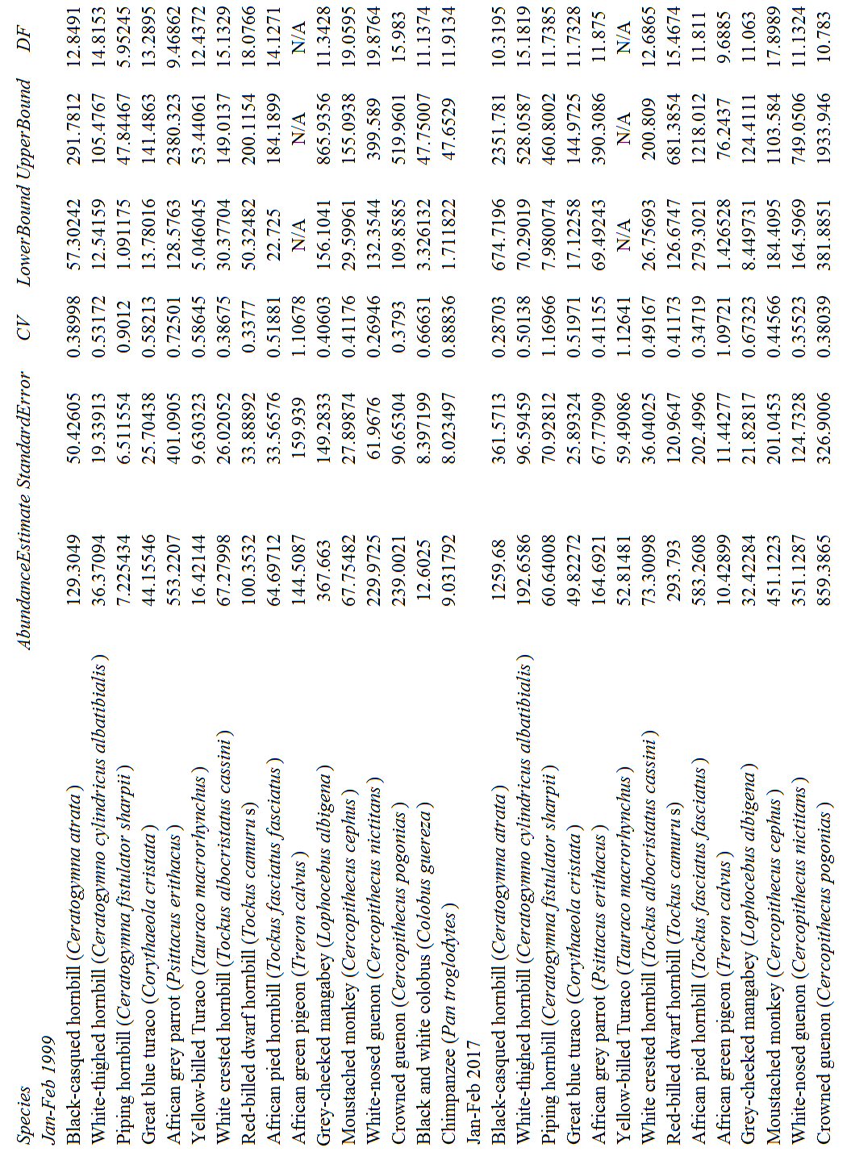

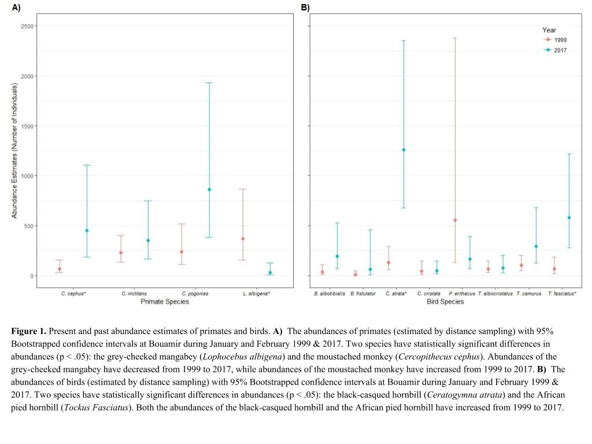

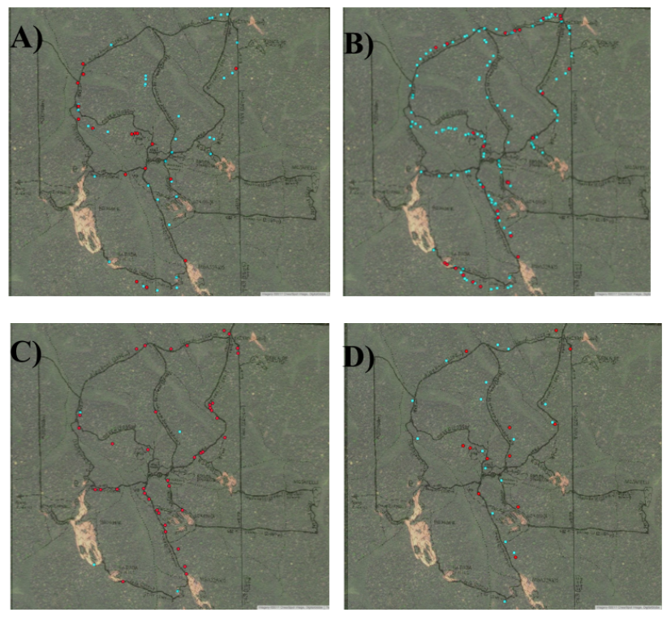

**Figure 2.** Spatial analysis of frugivore encounters in the past (red) versus present (blue). **A)** African pied hornbill (*T. fasciatus fasciatus*), **B)** black-casqued hornbill (*C. atrata*), **C)** grey-cheeked mangabey (*L. albigena*), **D)** moustached monkey (*C. cephus*).

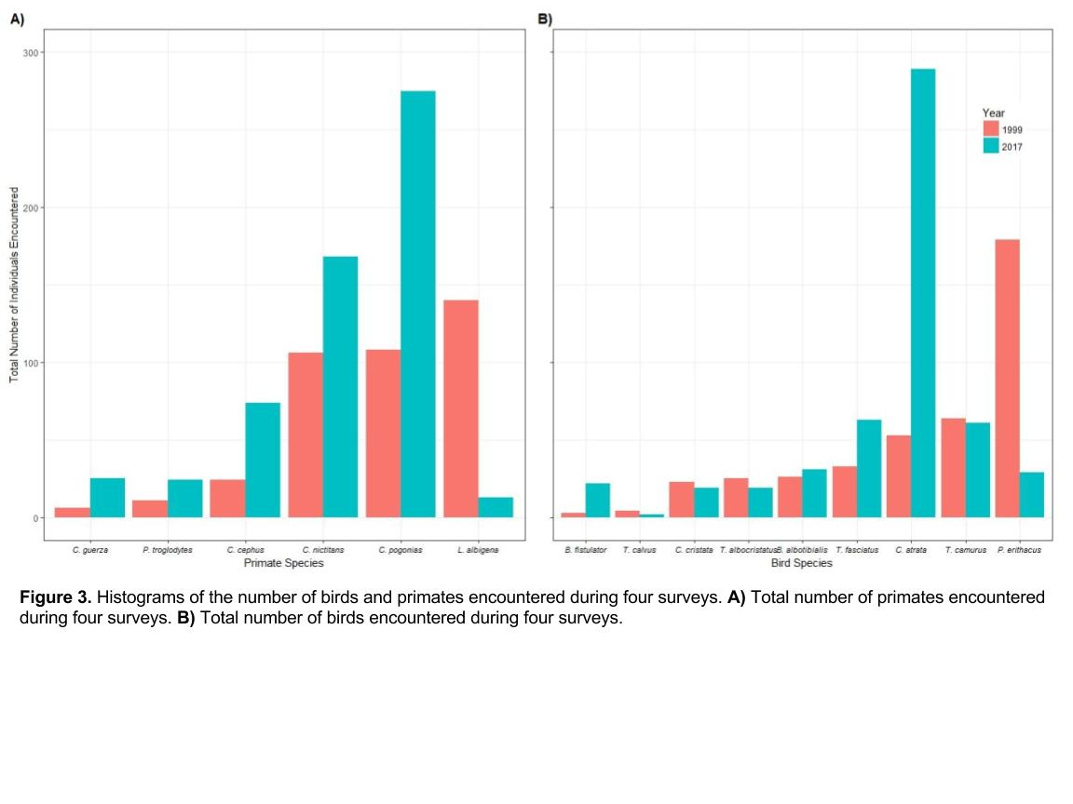

. 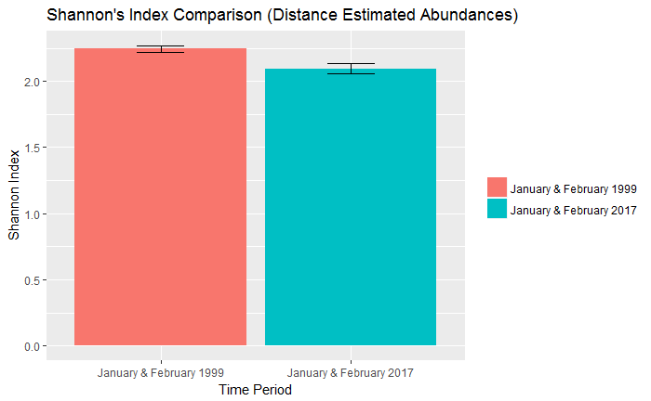

**Figure 4:** Shannon’s indices with *Distance* Abundances. The confidence intervals were computed with the Hutcheson’s t-test (p<0.005).

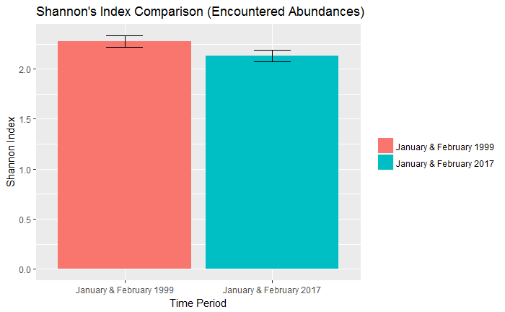

**Figure 5:** Shannon’s indices with encounter abundances. The confidence intervals were computed with the Hutcheson’s t-test (p<0.005).

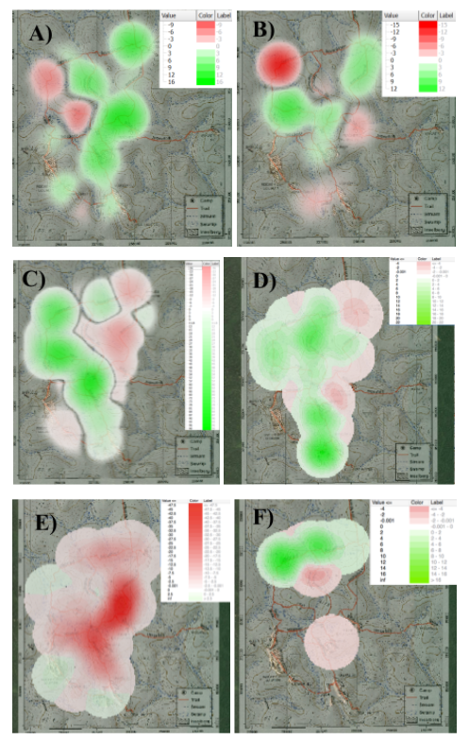

**Figure 6:** Kernel density plots of species distributions, present densities minus past densities. Areas shaded red indicate where past abundances were larger than present, while areas shaded green indicate where present abundances are higher than in the past. **A)** African pied hornbill (*T. faciatus faciatus*) **B)**white-thighed hornbill (*C. cylindricus albotibialis*)**C)** crowned guenon (*C. pogonias*) **D)** moustached monkey (*C. cephus*) **E)** grey-cheeked mangabey (*L. albigena*) **F)** chimpanzee (*P. troglodytes*).

**References**

Annorbah NND, Collar NJ, Marsden SJ. Trade and habitat change virtually eliminate the Grey Parrot *Psittacus erithacus* from Ghana. 2016. Ibis 158: 82-91.

BirdLife International. 2016. *Psittacus erithacus*. The IUCN Red List of Threatened Species.

Buckland ST, Rexstad EA, Marques TA, Oedekoven CS. 2015 *Distance sampling*. John Wiley & Sons, Ltd.

Campbell GH, Kuehl AD, N’goran PK, Boesch C. 2011. Long-term research sites as refugia for threatened and over-harvested species. Biology Letters 7.5: 723-26.

Celine E, Philippe M, Astrid V, Catherine B, Musampa C, Pierre D. National forest cover change in Congo Basin: deforestation, reforestation, degradation and regeneration for the years 1990, 2000 and 2005. Global Change Biology 19: 1173-1187.

Chapin III, Zavaleta E, Naylor R, Vitousek P, Reynolds H, Hooper D, Lavorel S, Sala O, Hobbie S., Hobbie S, Mack M, Diaz S. 2000. Consequences of Changing Biodiversity. Nature 405.6783 : 234–242.

Endamana D, Boedhihartono AK, Bokoto B, Defo L, Eyebe A, Ndikumagenge C, Nzooh Z, Ruiz-Perez M, Sayer JA. 2010. A framework for assessing conservation and development in a Congo Basin forest landscape. Tropical Conservation Science 3:262-281.

Environmental Systems Research Institute (ESRI). 2012. *ArcGIS Release 10.1*. Redlands, CA.

Fa JE, Olivero J, Farfan MA, Marquez AL, Duarte J, Nackoney J, Hall A, Dupain J, Seymour S, Johnson PJ, Macdonald DW, Real R, Vargas JM. 2015. Correlates of bushmeat in markets and depletion of wildlife. Conservation Biology 29: 805-815.

Fa JE, Ryan SF, Bell DJ. 2005. Hunting vulnerability, ecological characteristics and harvest rates of bushmeat species in Afrotropical forests. Biol. Conserv. 121: 167–176.

Fa JE, Seymour S, Dupain J, Amin R, Albrechtsen L, Macdonald D. 2006. Getting to grips with the magnitude of exploitation: Bushmeat in the Cross-Sanaga rivers region, Nigeria and Cameroon. Biological Conservation 129: 497-510.

Galford GL, Soares-Filho BS, Sonter LJ, Laporte N. 2015. Will passive protection save Congo forests? PLoS ONE 10: e0128473.

Green MJB, Dissanyake SRB. 2009. The importance of monitoring biological diversity and its application in Sri Lanka. Tropical Ecology: 41-56.

Holbrook KM, Smith TB, Hardesty BD. 2002. Implications of long-distance movements of frugivorous rain forest hornbills. Ecography 25: 745-749.

Hutcheson K. 1970. A test for comparing diversities based on the shannon formula. Journal of Theoretical Biology 29.1: 51-154.

Jordano, P. 1992. Seeds: The ecology of regeneration in plant communities, pp. 105–156. Commonwealth Agricultural Bureau International, Wallingford, UK .

Kingdon, J. 2015. The Kingdon field guide to African mammals. Princeton University Press, Princeton, NJ, USA.

Kumpel NF, 2006. Incentives for sustainable hunting of bushmeat in Rio Muni, Equatorial Guinea. PhD Thesis, Imperial College London, London, UK.

Lemieux J, Cusson M. 2014. Effects of Habitat-Forming Species Richness, Evenness, Identity, and Abundance on Benthic Intertidal Community Establishment and Productivity. PLoS ONE: 9-10.

Magurran AE, Baillie SR, Buckland ST, Dick JM, Elston DA, Scott EM, Smith RI, Somerfield PJ, Watt AD. 2010. Long-term datasets in biodiversity research and monitoring: assessing change in ecological communities through time. Trends in Ecology & Evolution 25: 74-82.

Marsden SJ, Loqueh E, Takou JM, Hart JA, Abani R, Ahon DB, Annorbah NND, Johnson R, Valle S. 2015. Using encounter rates as surrogates for density estimates makes monitoring of heavily-traded grey parrots achievable across Africa. Oryx 50: 617-625.

Miller, DL (2016). Distance: Distance Sampling Detection Function and Abundance Estimation. R package version 0.9.6. https://CRAN.R-project.org/package=Distance

Morris E, Tancredi Caruso K, Buscot F, Fischer M, Hancock C, Maier TS, Meiners T, Müller C, Obermaier E, Prati D, Socher SA, Sonnemann I, Wäschke N, Wubet T, Wurst S, Rillig MC. 2014. Choosing and using diversity indices: insights for ecological applications from the German Biodiversity Exploratories. Ecology and Evolution 4: 3514-524.

Muchaal PK, Ngandjui G. 1999. Impact of village hunting on wildlife populations in the Western Dja Reserve, Cameroon. Conservation Biology 13: 385-396.

Oates JF. 1996. Habitat alteration, hunting and the conservation of folivorous primates in African forests. Australian Journal of Ecology 21: 1-9.

Poulsen JR, Koerner SE, Moore S, Medjibe VP, Blake S, Clark CJ, Akou ME, Fay M, Meier A, Okouyi J, Rosin C, White LJT. 2017. Poaching empties critical Central African wilderness of forest elephants. Current Biology 27: 134-135.

Remis MJ, Jost Robinson CA. 2012. Reductions in primate abundance and diversity in a multiuse protected area: synergistic impacts of hunting and logging in a Congo Basin Forest. American Journal of Primatology 74: 602-612.

Trail PW. 2007. African hornbills: keystone species threatened by habitat loss, hunting and international trade. Ostrich 78: 609-613.

Wang BC, Sork VL, Leong MT, Smith TB. 2007. Hunting of mammals reduces seed removal and dispersal of the afrotropical tree Antrocaryon Klaineanum (Anacardiaceae). Biotropica 39: 340-47.

Whitney KD, Fogiel MK, Lamperti AM, Holbrook KM, Stauffer DM, Hardesty BD, Parker VT, Smith TB, French AR, Poulsen JR, Wang B, Clark CJ. 1998. Dja Hornbill Report.

Whitney KD, Fogiel MK, Lamperti AM, Holbrook KM, Stauffer DM, Hardesty BD, Parker VT, Smith TB, French AR, Poulsen JR, Wang B, Clark CJ. Unpublished results. Bouamir Frugivore, Feeding and Abundance. Unpublished Raw Data.

Whitney KD and Smith TB. 1998. Habitat use and resource tracking by African *Ceratogymn* hornbills: implications for seed dispersal and forest conservation. Animal Conservation 1: 107-117.

World Heritage Center. 2016. Convention concerning the protection of the world cultural and natural heritage: WHC/16/40.COM/7B. United Nations Education, Scientific, and Cultural Organization 40: 143-146.

**Appendix**

**A. Map of The Bouamir Research Station.**

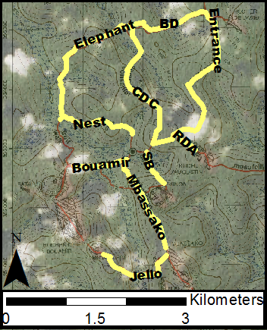

The ten trails that we surveyed are highlighted in yellow.

**B. Distribution of Encounters in 2017 and 1999**

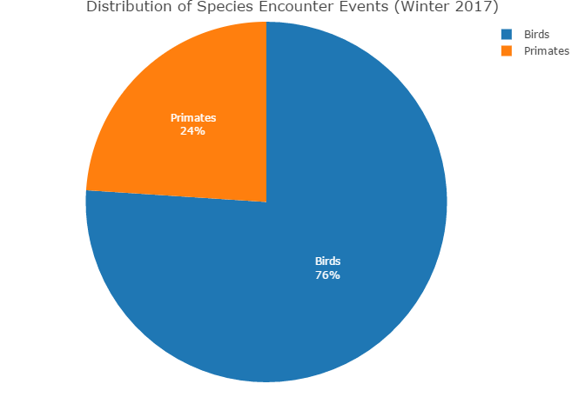

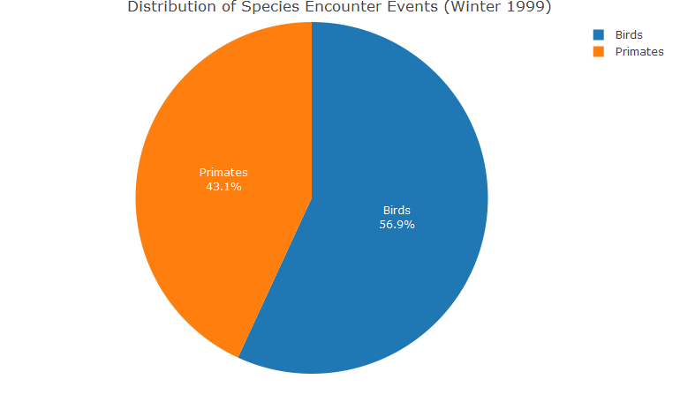

Pie Chart of encounter events.This graph is not incorporating the estimated group size of the encounter. It is merely presenting the amount of times we encountered a group/individual of a specific species.

**C. Distribution of Encountered Abundances in 2017 and 1999**

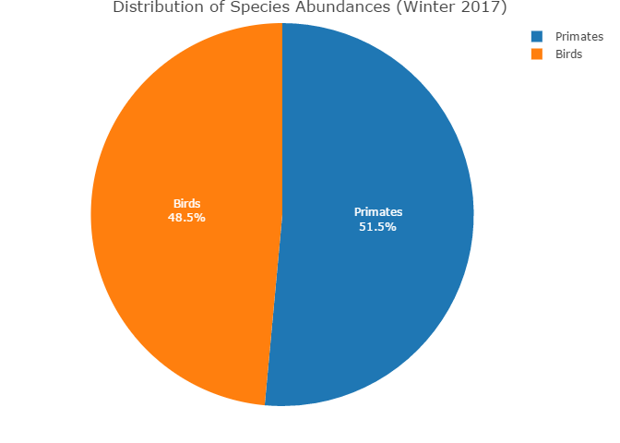

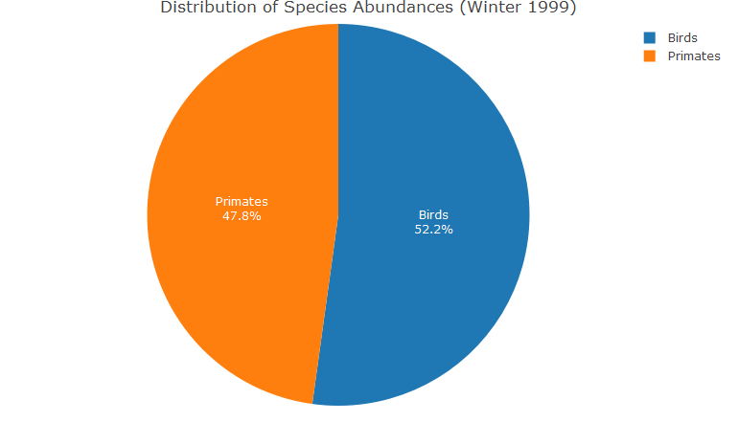

Pie chart of amount of individuals of each species we encountered on our surveys. This graph is incorporating the estimated group size of each encounter.Not estimated abundances using distance sampling.